Exp. 4. Kronig Penney Model
Aim: To simulate Energy functional vs Energy graph using Kronig Penney model
OUTPUT:
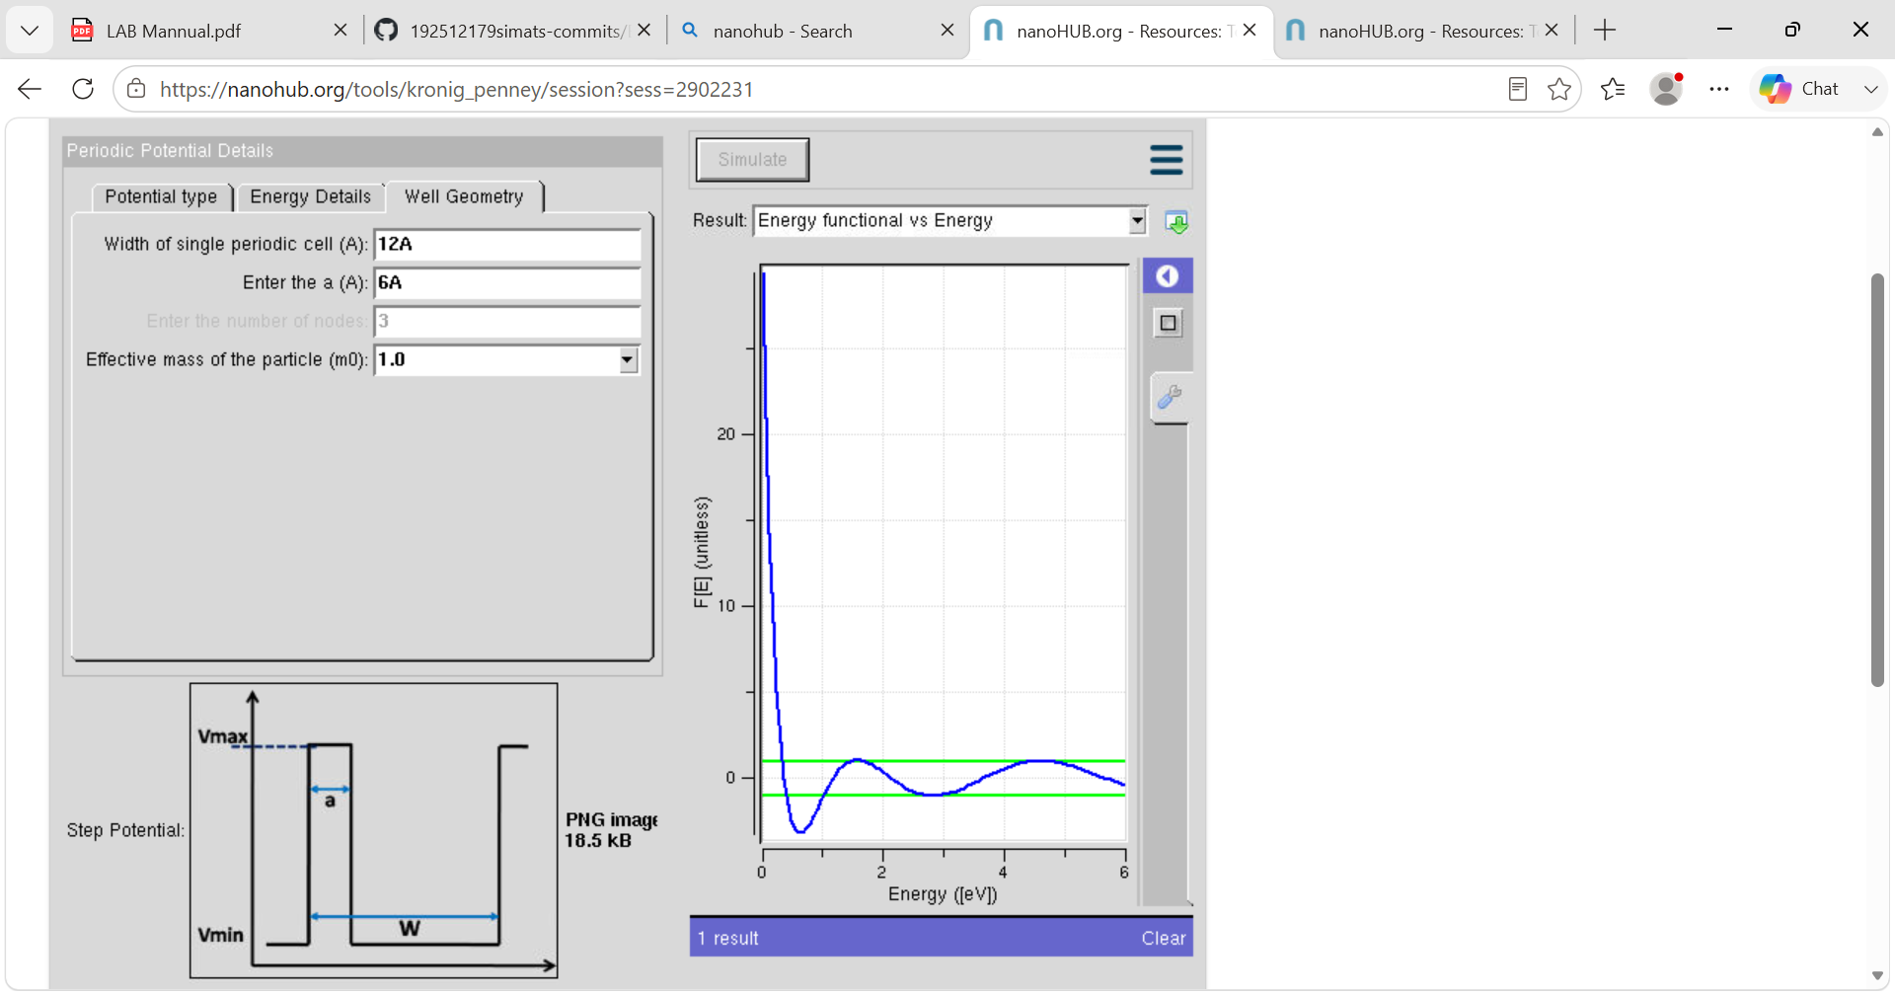
Case Study 1: Simulate the output for Triangular well
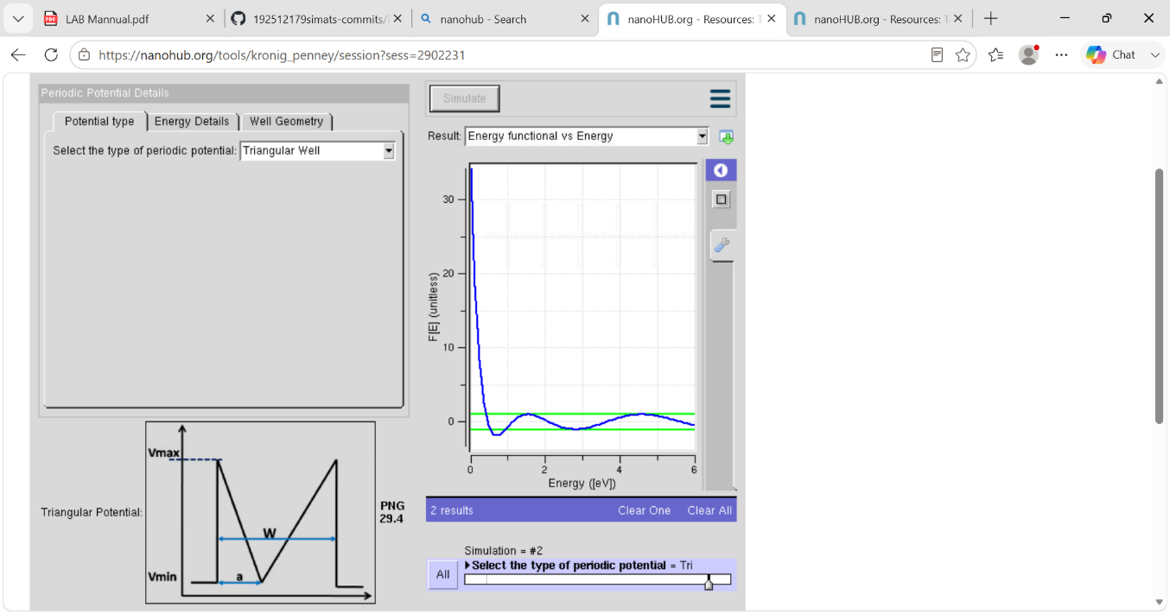

Case Study 2: Simulate the output for Sinusoidal Potential
